Problem 1 (20 points):
You are investigating a new enzyme that takes a simple substrate, S, and converts it into a much desire product, P. You realize that this transpires through the simple enzymatic reaction:
You are tasked with discovering the kinetics of this enzyme.
- You note in studying the enzyme that the forward reaction rate, k_{f} is 10 times faster than the reverse reaction rate, k_{r}, i.e., k_{f} = 10k_{r}.
- You start with and initial concentration of the substrate, S = s₀ and you measure the amount of product, P, produced in the first minute as the initial velocity of the reaction as V₀ (mMoles/min)
- You use 10 mMoles of enzyme (e₀=10 mMoles)
- The table below gives you the following results of your experiments:
Initial Substrate, S₀  Moles | Initial Velocity, V₀  mMoles/min
1 | 1.25
3 | 2.5
9 | 3.75
12 | 4.0

Let the initial concentration of C, c₀ = 0, and the initial concentration of P, p₀ =0
Find the only correct statement below and explain or demonstrate why.
- k₁ ≈ 1.724/min
- V_{max} = 5 mM/min
- K_{m} = 5.0 mM
- k₂ = 5/min

$$v_{max}=\frac{1}{b}=\frac{1}{0.2}=5\frac{mMol}{min}$$
$$k_{m}=m⋅v_{max}=0.6⋅5=3\frac{1}{min}$$
$$k_{2}=\frac{e_{o}}{v_{max}}=\frac{10 mMol}{5\frac{mMol}{min}}=0.5 \frac{1}{min}$$
$$k_{m}=\frac{k_{r}+k_{2}}{k_{f}}, where k_{f}=10k_{r}$$
$$k_{m}=\frac{k_{r}+k_{2}}{10k_{r}}$$
$$10k_{m}k_{r}-k_{r}=k_{2}$$
$$k_{r}\left(10k_{m}-1\right)=k_{2}$$
$$k_{r}=\frac{k_{2}}{10k_{m}-1}$$
$$k_{r}=\frac{k_{2}}{10k_{m}-1}=\frac{0.5 \frac{1}{min}}{10\left(3 \frac{1}{min}\right)-1}=0.01724 \frac{1}{min}$$
$$k_{f}=10\left(k_{r}\right)=10\left(0.01724\frac{1}{min}\right)=0.1724\frac{1}{min}$$
$$\frac{ⅆS}{ⅆt}=-0.1724\frac{1}{min}∙S\left(e_{0}-C\right)+0.01724\frac{1}{min}∙C$$
$$\frac{ⅆC}{ⅆt}=0.1724\frac{1}{min}∙S\left(e_{0}-C\right)-\left(0.01724\frac{1}{min}+0.5\frac{1}{min}\right)C$$
$$\frac{ⅆP}{ⅆt}=C∙0.01724\frac{1}{min}$$

- Develop the dynamical formulas for this reaction (3 differential equations that explicitly and exactly describe the reaction)
- Simulate the full enzyme reaction in Simulink.
- Make 2 plots: 1- complex formation phase in one simulation done over a short time horizon (1 min) and
- followed by the full product formation simulation done over a longer time horizon(30 min).
- Finally, develop the Michaelis - Menten equation for this reaction.
  - Plot Michaelis Menten equation result against the full dynamical equations on the same plots made in part a.
  - What are differences between the graphs in each plot. That is, explain what and why the two plots do not coincide.
The michealis-menten model always has a underacheivement when it comes to assuming the cocnentrations. Also C spikes but slowly goes back to zero around 30 minutes. While P reaches a max of the same as the intial value of S. the graphs are different because each reaction has a different reaction rate and intial vlaue which effect there comsuption or growth.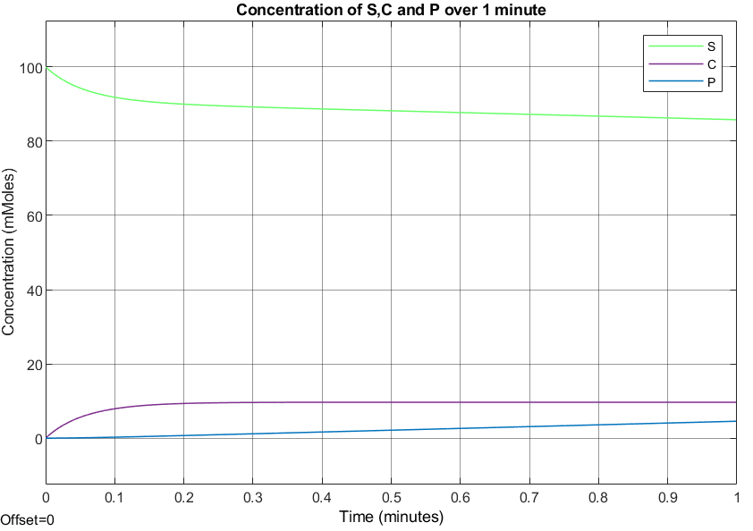
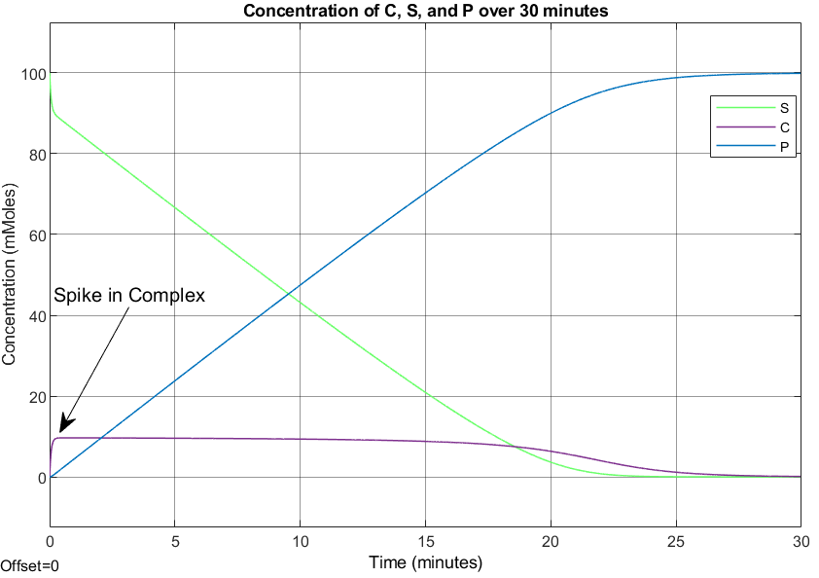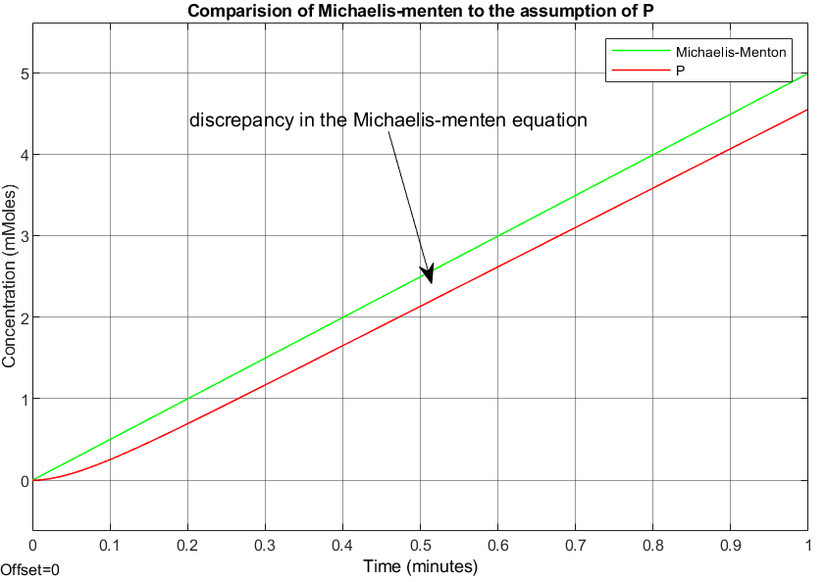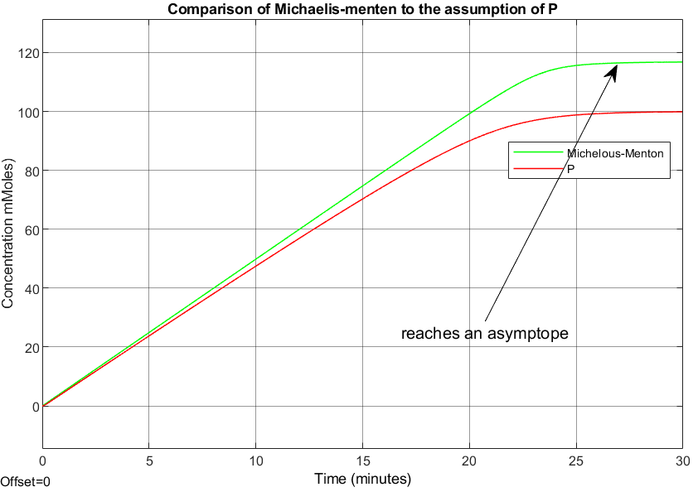
Problem 2 (20 points):

You are investigating a new enzyme through Michaelis Menten kinetics, and you have found that it has a maximum velocity of 6.0 $μ$M/s when the [E]₀ is 1.5 x 10⁻⁹ M based on the following data:

Initial velocity (V₀) | [S]₀
1.0 $μ$M/s | 20 mM
2.0 $μ$M/s | 50 mM
3.0 $μ$M/s | 100 mM
4.0 $μ$M/s | 200 mM
5.0 $μ$M/s | 500 mM

- Determine K_{m} of this enzymatic reaction (Hint: before going to do a lot of calculations, stop to THINK how this might be determined! – if it doesn’t come to you, go ahead and do a lot of calculations. I suggest MS Excel for the calculations though Matlab works)
$$\frac{1}{V_{0}}=\frac{K_{m}}{V_{max}*S}+\frac{1}{V_{max}}$$
$$slope=\frac{K_{m}}{V_{max}}$$
$$0.0167*6=0.1/sec$$

- Plot the full Michaelis-Menten reaction using either Matlab or Simulink. Caution: This is not a plot of the data! The data gives you V₀ for each S₀. You have V_{max} as given. You found K_{M}. What you want is product as a function of time. Be careful of the units. The reaction is slow and you will need a longer runtime
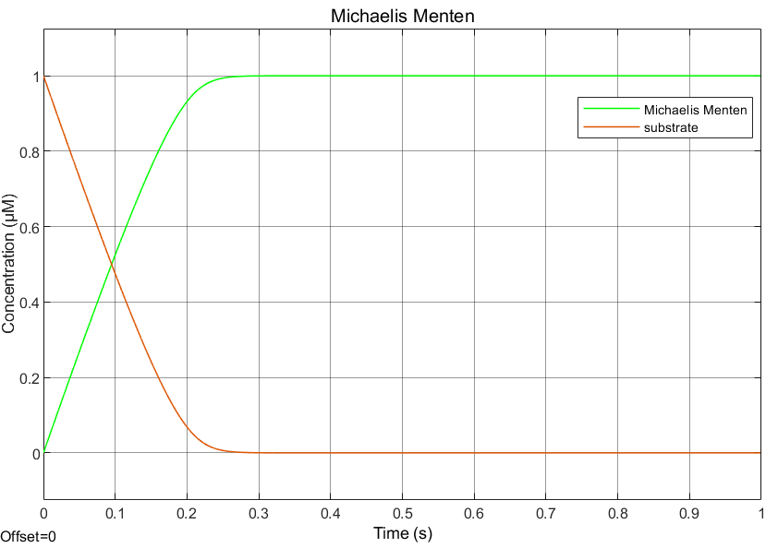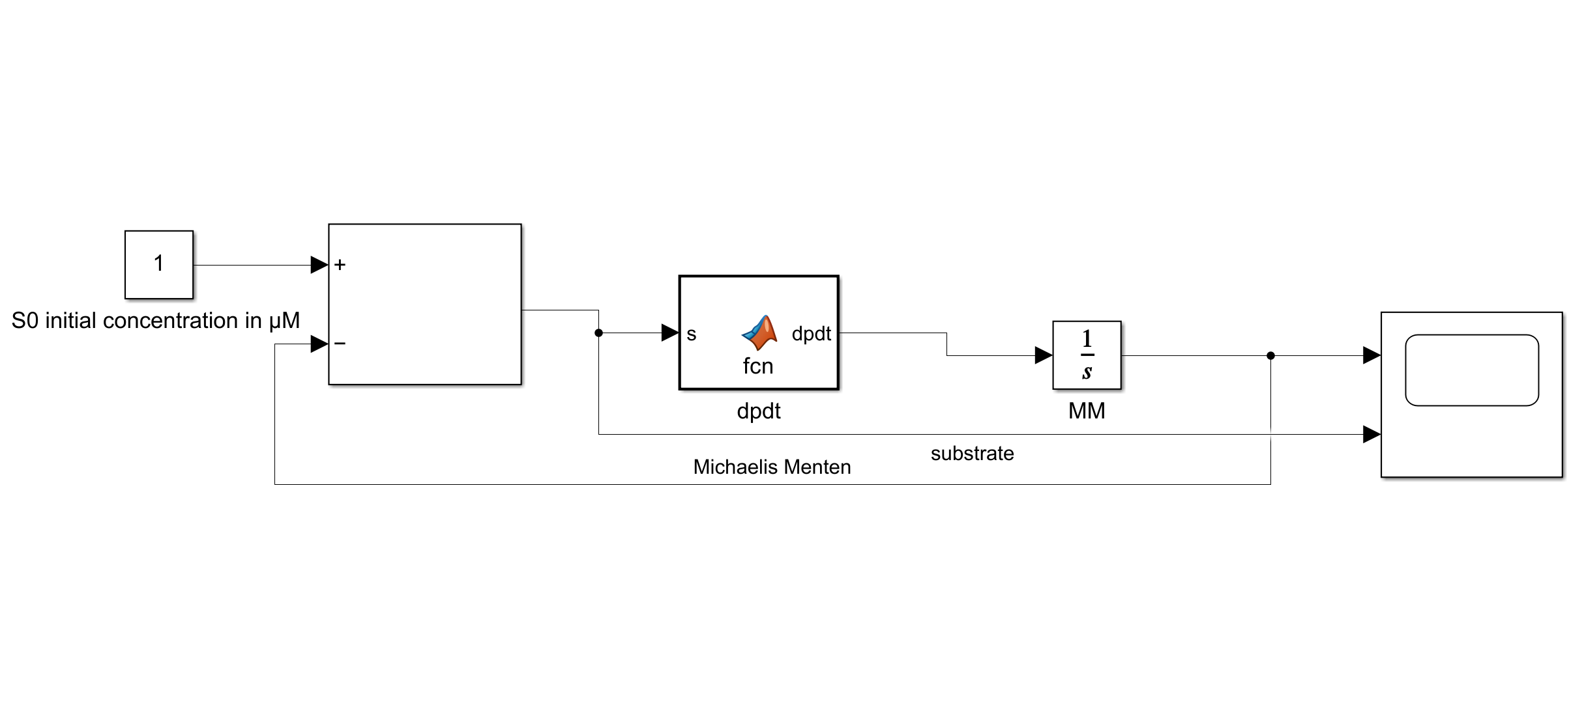
Problem 3 (20 points): (Multiple Choice Questions requiring Explanations)
Which statements about enzyme catalyzed reactions are NOT true? Explain your answer and explain why the statements that are not true are false Enzymes form complexes with their substrates
  - Enzymes lower the energy of activation for chemical reactions
TRUE- enzymes have a specific active site that binds with a substrate bringing them closer and positioning them in the correct orientation to reduce the need for collections thus reducing the energy activation.
  - Enzymes change the equilibrium constant (K_{eq} or K_{ss}) for chemical reactions
FALSE- they do not change the constant. Enzymes are catalysts so they only speed up the reaction and do not change any equilibrium constant. The constant is only dependent on the energy level difference between product and reaction.
  - Many enzymes undergo conformational changes when binding with substrate
TRUE- enzymes go through something called induced fit where the enzyme slightly changes in allow for a better fit of the substrate.
  - For enzymatic reactions to occur at the “active site” of enzymatic proteins, the 3D orientation of substrate molecules is an important feature of the reaction
TRUE-the active sits are specifically shaped to only bind to certain substrates with the correct orientation. Enzymes are 3D so there is this need for the substrate to have the correct x,y,z positions.
  - Enzyme inhibition can always be overcome by adding more substrate
FLASE- this question does not identify either competitive or noncompetitive inhibition, thus this is false. Competitive inhibition can be overcome by increasing the substrate concentration a noncompetitive does not bind to the active site thus affecting the enzyme activity regardless of the concentration of the substrate.
Problem 4 (20 points)
Consider the following set of data and answer the following questions:
[S] Moles | V (umol/min) | V (+inhibitor) umol/min
6.00E-06 | 20.8 | 12
1.00E-05 | 29 | 15
2.00E-05 | 45 | 20
6.00E-05 | 67.6 | 24
1.80E-04 | 87 | 27
3.00E-04 | 92 | 27

- Plot the data (the velocities are the initial velocities) on a Lineweaver-Burk plot (be sure to label axes) 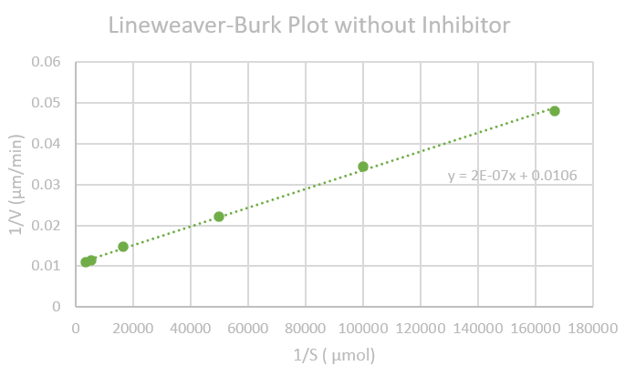
- Determine the Vmax & Km of the reaction without the inhibitor
$$y=2×{10}^{-7}+0.0106$$
$$v_{max}=\frac{1}{0.0106}=94.34\frac{μmol}{mol}$$
$$k_{m}=M⋅v_{max}=1.89×{10}^{-5}\frac{1}{min}$$

- The second set of velocities represents the rate of the reaction when the inhibitor is added. Plot these data on the same graph as above.
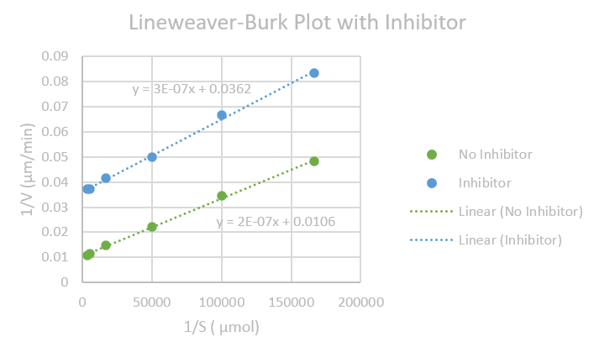
- Do the two trendlines seem parallel? They nearly seem perfectly parallel.

- Looking at their slopes by what factor are they not parallel.
The slope of the inhibitor is 3E-07 while the inhibitor has 2E-07 so they are definitely not parallel.
- Given that this is actual experimental data, do you think the difference is significant?
No, there could have been some issue with contamination in the sample without the inhibitor to why there is a different slope.
- State the type of inhibition is present (competitive, non-competitive,
uncompetitive). uncompetitive
- Can the effects of the inhibitor be over-ridden by adding more substrate? If so, explain why?
No, uncompetitive inhibitors only bind to enzyme substrate complex. Not the free enzyme.
PROBLEM 5 (20 points)

PhosphoFructokinase-1 (PFK-1) is an essential enzyme in glycolysis. It converts fructose-6-phosphate (F-6-P) to fructose -1,6 – biphosphate (F-1,6-BP) You have a lab experiment with this enzyme, and you derive the following experimental data (13 initial substrate concentrations and 13 velocity measurements):

F-6-P Concentration  S(0) | Velocity of production of F-1,6-BP
0.1 | 0.1
0.5 | 1.1
1 | 3
2 | 9
3 | 15
5 | 22
7 | 26
10 | 28
13 | 29
16 | 29.5
18 | 30
20 | 30
24 | 30

- Plot the experimental data.
- Does this data and plot suggest Michaelis-Menten dynamics or Hill dynamics. Hill dynamics
- If your answer was Michaelis-Menten dynamics, derive the K_{m} and V_{max} but if your answer were Hill dynamics, derive the Hill coefficient, the Hill K, and V_{max}

% Experimental data
F6P_concentration = [0.1, 0.5, 1, 2, 3, 5, 7, 10, 13, 16, 18, 20, 24];
velocity = [0.1, 1.1, 3, 9, 15, 22, 26, 28, 29, 29.5, 30, 30, 30];

% Plotting the data
figure;
plot(F6P_concentration, velocity, 'o-', 'LineWidth', 2);
xlabel('F-6-P Concentration (mM)');
ylabel('Velocity of production of F-1,6-BP (µM/min)');
title('PFK-1 Enzyme Kinetics');
grid on;


% Hill model
hill_model = @(params, S) params(1) * S.^params(2) ./ (params(3).^params(2) + S.^params(2));

% Initial guess for parameters [Vmax, n, Kd]
initial_guess = [30, 2, 3];

% Extract parameters
Vmax = params(1);
Hill_n = params(2);
Kd = params(3);

fprintf('Hill dynamics parameters:\n Vmax = %.2f µM/min\n Hill coefficient = %.2f\n Hill constant (Kd) = %.2f mM\n', Vmax, Hill_n, Kd);
Hill dynamics parameters:
Vmax = 30.70 µM/min
Hill coefficient = 1.99
Hill constant (Kd) = 3.08 mM

Bottom of Form

